Correspondence on our last domain analysis and program

Constants -> Constants

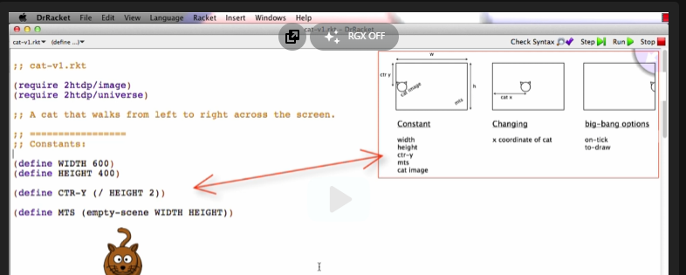

Changing -> Data Definition

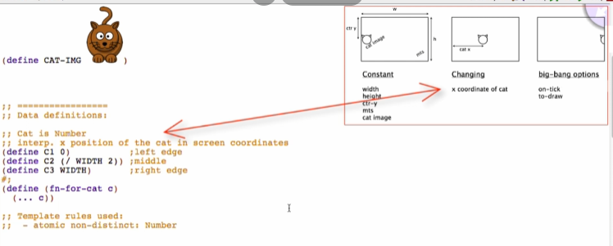

Big-bang options -> World function options

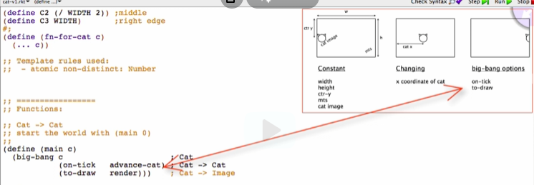

Options -> handler functions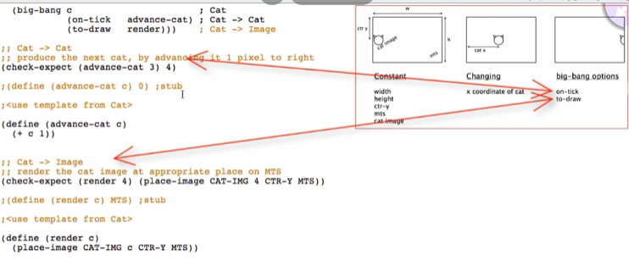

Refactoring: Starting at the analysis

Analysis

* Model of the program
* Because it correctly describes the structure of the program but has less detail, we can plan our work on the program by marking up the analysis

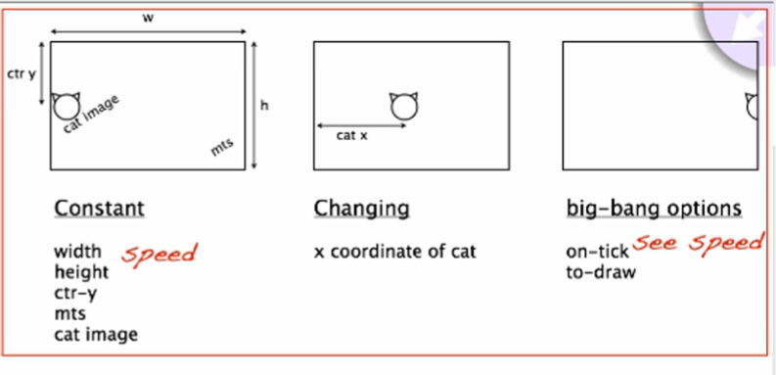

Refactoring the program

@Constants:

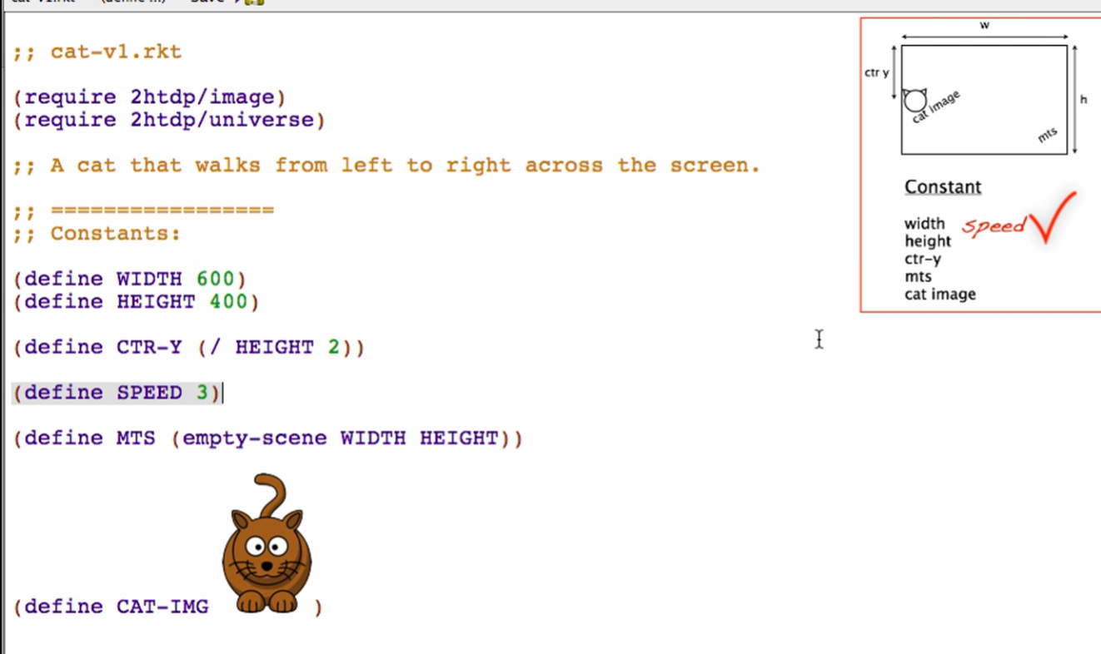

@on-tick handler

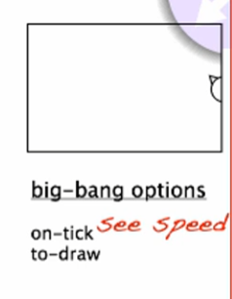 -> go to on-tick -> Jump to the definition of the advance cat:

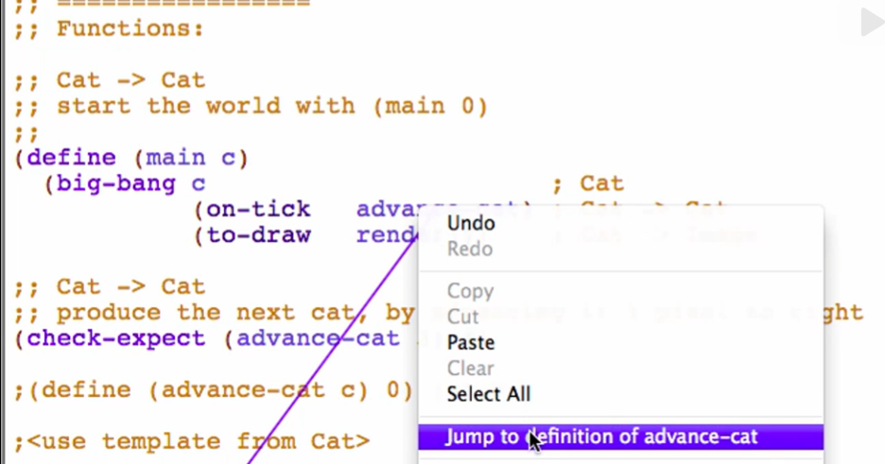

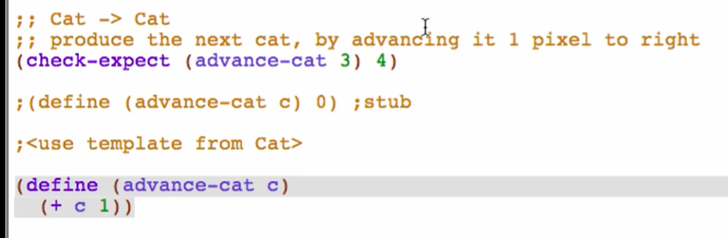

Changing the advance-cat function:

**Signature –** does not change

**Purpose**



**Stub –** does not change

**Examples**



Note: use constants in check-expects

* Make examples clearer and more correct so you don’t have to change the examples when you make changes in the constant

Template – does not change

**Code Body**

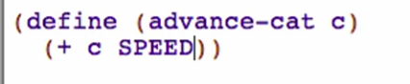

Run, and call main

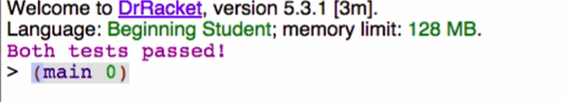

Check if cat increase the speed

Note: program always change if people is really using it